

|  |  |
| --- | --- |
| **Course Number** | COE 70B |
| **Course Title** | Computer Vision Based AI for Human Pose Detection |
| **Semester/Year** | W2021 |
| **Instructor Name** | Dr. Alagan Anpalagan |
| **Team Number** | AA06 |

|  |  |
| --- | --- |
| **Submission Date** | April 13, 2021 |
| **Due Date** | April 13, 2021 |

|  |  |  |
| --- | --- | --- |
| **Name** | **Student ID** | **Signature\*** |
| Vatsal Shreekant | 500771363 |  |

*\*By signing above, you attest that you have contributed to this submission and confirm that all work you have contributed to this submission is your own work. Any suspicion of copying or plagiarism in this work will result in an investigation of Academic Misconduct and may result in a “0” on the work, an “F” in the course, or possibly more severe penalties, as well as a Disciplinary Notice on your academic record under the Student Code of Academic Conduct, which can be found online at:*

*www.ryerson.ca/senate/current/pol60.pdf*

Contents

**1** **Pre-Lab** 3

1.2 Drain current equations for an ideal NMOS and PMOS Transistor & Ids-Vds Curves 3

*Equation 1: Drain Current for ideal NMOS Transistor* 3

*Figure 1: I-V Characteristics of Waveforms for ideal NMOS Transistor* 3

*Equation 2: Drain Current for ideal PMOS Transistor* 3

*Figure 2: I-V Characteristics of Waveforms for ideal PMOS Transistor* 4

1.3 Equation for the Threshold Voltage of a MOS Transistor 4

*Equation 3: Threshold Voltage for a MOS Transistor* 4

1.4 Channel Length Modulation (CLM) 4

*Equation 4: Drain Current Equation Modified to Account for CLM* 4

1.5 Subthreshold Current 5

*Equation 5: Drain Current when the Transistor Operates in the Subthreshold Region* 5

1.6 Symbol for NMOS Transistor and it’s Intrinsic Capacitances 5

*Figure 3: Symbol for NMOS with Intrinsic Capacitances* 5

**2** **Post-Lab** 6

2.1 Schematic for NMOS and PMOS Transistors 6

*Figure 4: Schematic for NMOS Transistor* 6

*Figure 5: Schematic for PMOS Transistor* 6

2.2 Family of I-V Characteristic Waveforms for NMOS and PMOS Transistors 7

*Figure 6: I-V Characteristics of Waveforms for NMOS Transistor* 7

*Figure 7: I-V Characteristics of Waveforms for PMOS Transistor* 7

2.3 Subthreshold Conduction for NMOS and PMOS Transistors 8

*Figure 8: Subthreshold Current for NMOS Transistor* 8

*Figure 9: Subthreshold Current for PMOS Transistor* 8

2.4 Body Effect Analysis for NMOS and PMOS Transistors 9

*Figure 10: Body Effect Analysis for NMOS Transistor* 9

*Figure 11: Body Effect Analysis for PMOS Transistor* 9

2.5 Layout and Extracted View of NMOS Transistor 10

*Figure 12: Layout View of NMOS Transistor* 10

*Figure 13: Extracted View of NMOS Transistor* 10

2.6 Family of I-V Characteristics of Waveforms for the Schematic and Extracted NMOS Transistor 11

*Figure 14: I-V Characteristics for Schematic NMOS Transistor* 11

*Figure 15: I-V Characteristics for Extracted NMOS Transistor* 11

3 Conclusion 11

# **1 Pre-Lab**

## 1.2 Drain current equations for an ideal NMOS and PMOS Transistor & Ids-Vds Curves

NMOS Transistor:

$$I_{ds}= \left\{\begin{aligned}0 , V_{gs}<V_{t}(Cutoff) \\ β\left(V_{gt}-\frac{V_{ds}}{2}\right)*V_{ds}, V_{ds}<V_{gs}-V_{t}, { V}_{gs}>V_{t}(Linear) \\ \frac{β}{2}*{V_{gt}}^{2}, V_{ds}≥V_{gs}-V_{t}, { V}_{gs}>V_{t}(Saturation)\end{aligned}\right.$$

### *Equation 1: Drain Current for ideal NMOS Transistor*

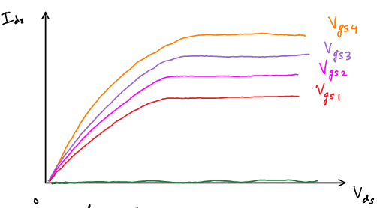

### *Figure 1: I-V Characteristics of Waveforms for ideal NMOS Transistor*

PMOS Transistor:

$$Isd= \left\{\begin{aligned}0 , V_{sg}≤{|V}_{tp}| (Cutoff) \\ β_{p}\left(V_{sg}-{|V}_{tp}|-\frac{V_{sd}}{2}\right)*V_{sd}, V_{sd}<V_{sg}-{|V}_{tp}| (Triode Region) \\ \frac{β_{p}}{2}{(V_{sg}-{|V}_{tp}|) }^{2}, V_{sd}>V_{sg}-{|V}_{tp}| (Saturation)\end{aligned}\right.$$

### *Equation 2: Drain Current for ideal PMOS Transistor*

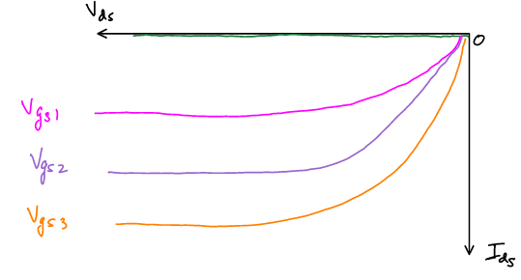

### *Figure 2: I-V Characteristics of Waveforms for ideal PMOS Transistor*

## 1.3 Equation for the Threshold Voltage of a MOS Transistor

$$V_{t}=V_{to}+γ(\sqrt{φ_{s}+V_{sb }}-\sqrt{φ_{s}})$$

### *Equation 3: Threshold Voltage for a MOS Transistor*

When a voltage Vsb is applied, the threshold voltage increases. It is evident from the equation that when Vsb decreases, Vt decreases as well.

## 1.4 Channel Length Modulation (CLM)

Assuming that the surface voltage is approximately the body voltage, that is, Vdb = Vds; the effective channel length Leff = L-Ldt(depletion region).

Ld increases as Vdb increases.

A shorter channel length equals to a higher current.

Hence, Ids increases with Vds in saturation.

The drain current is modified to account for CLM as follows:

$$I_{ds}=\frac{β}{2}{\left( V_{gs}-V_{t}\right)}^{2}*(1+\frac{V_{ds}}{V_{A}})$$

### *Equation 4: Drain Current Equation Modified to Account for CLM*

## 1.5 Subthreshold Current

In an ideal transistor, the current doesn’t get cut-off when Vgs<Vt. It rather drops exponentially. The subthreshold leakage current increases significantly with Vds due to drain induced barrier lowering.

There is a lower limit on Ids set by drain junction leakage.

$$I_{ds}=I_{ds0}*e^{\frac{V_{gs}-V_{to}+nV_{ds}-K_{γ}V_{sb}}{nV_{t}}}(1-e^{-\frac{V_{ds}}{V_{t}}})$$

### *Equation 5: Drain Current when the Transistor Operates in the Subthreshold Region*

## 1.6 Symbol for NMOS Transistor and it’s Intrinsic Capacitances

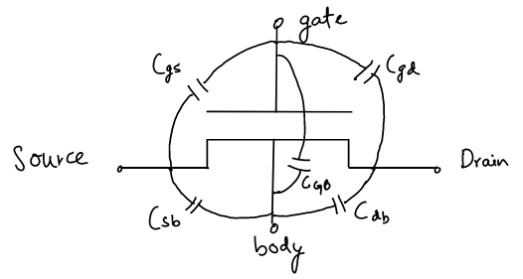

### *Figure 3: Symbol for NMOS with Intrinsic Capacitances*

# **2 Post-Lab**

## 2.1 Schematic for NMOS and PMOS Transistors

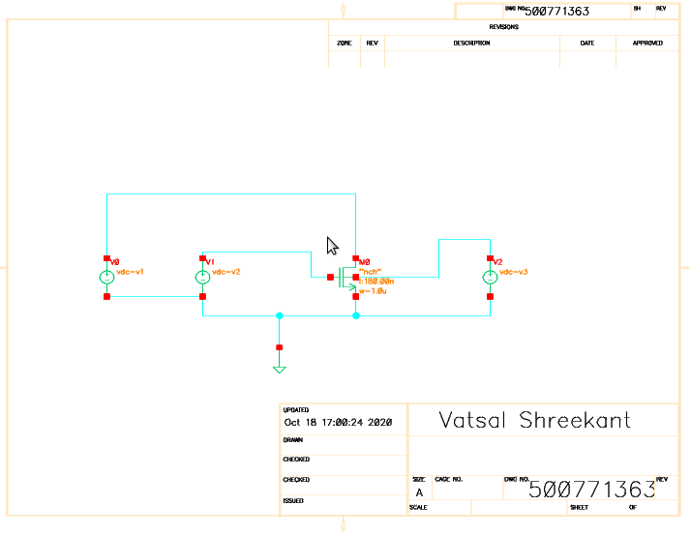

### *Figure 4: Schematic for NMOS Transistor*

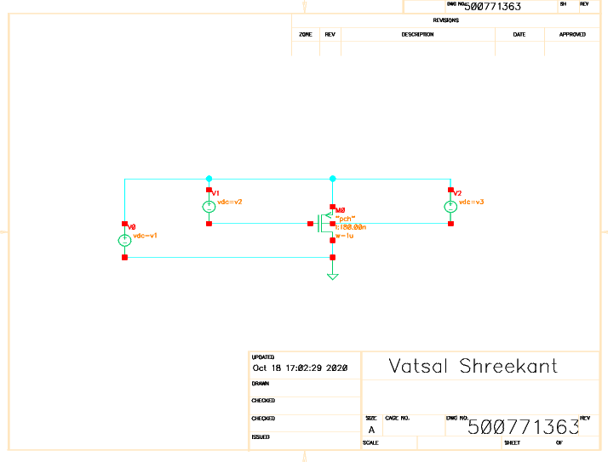

### *Figure 5: Schematic for PMOS Transistor*

## 2.2 Family of I-V Characteristic Waveforms for NMOS and PMOS Transistors

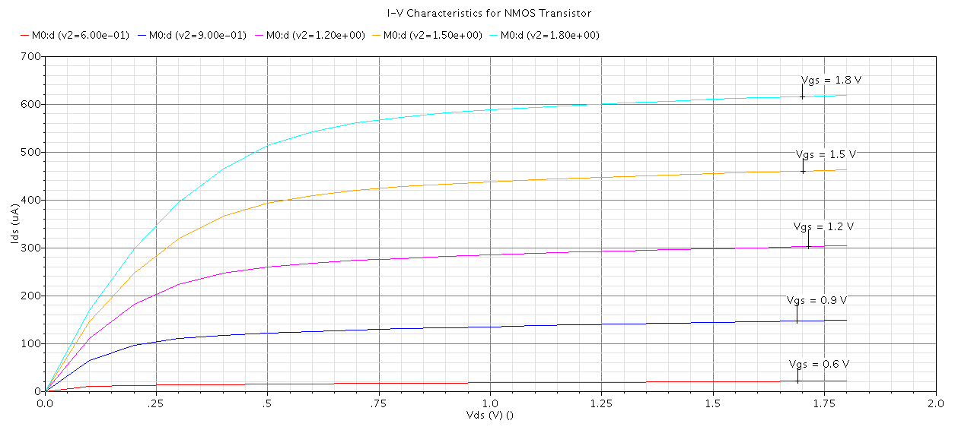

### *Figure 6: I-V Characteristics of Waveforms for NMOS Transistor*

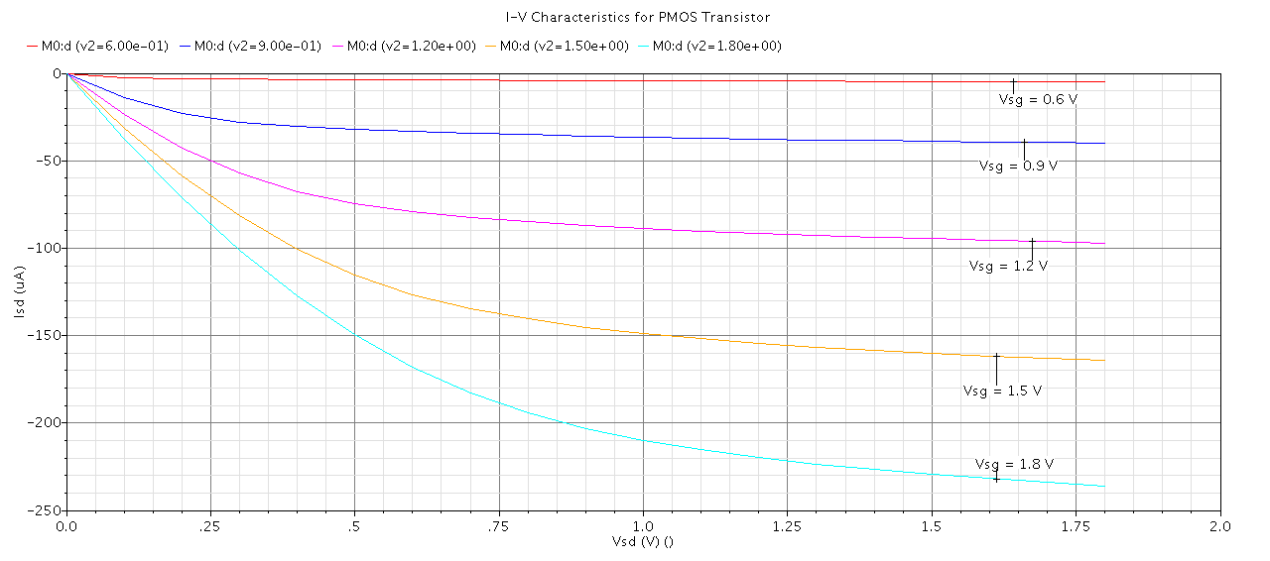

### *Figure 7: I-V Characteristics of Waveforms for PMOS Transistor*

## 2.3 Subthreshold Conduction for NMOS and PMOS Transistors

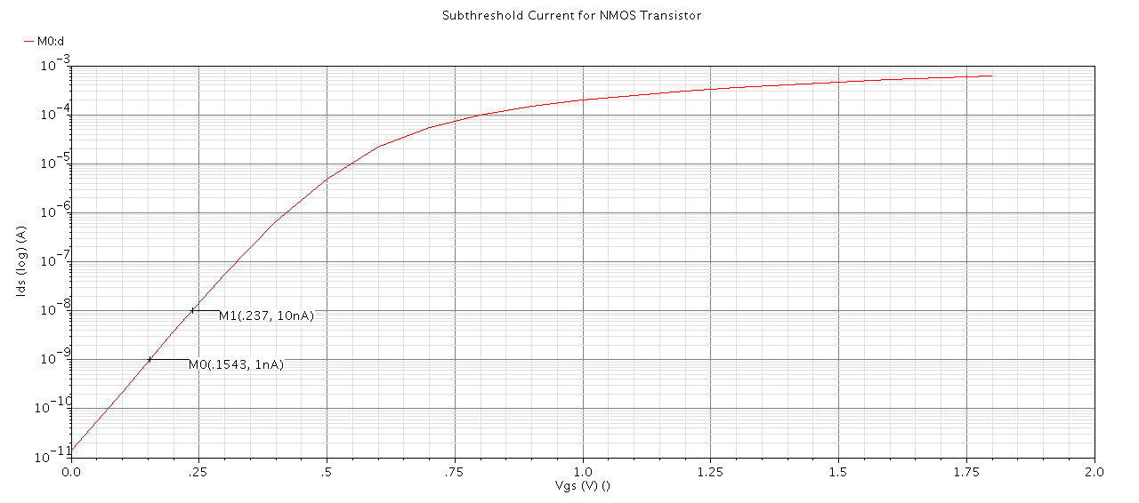

### *Figure 8: Subthreshold Current for NMOS Transistor*

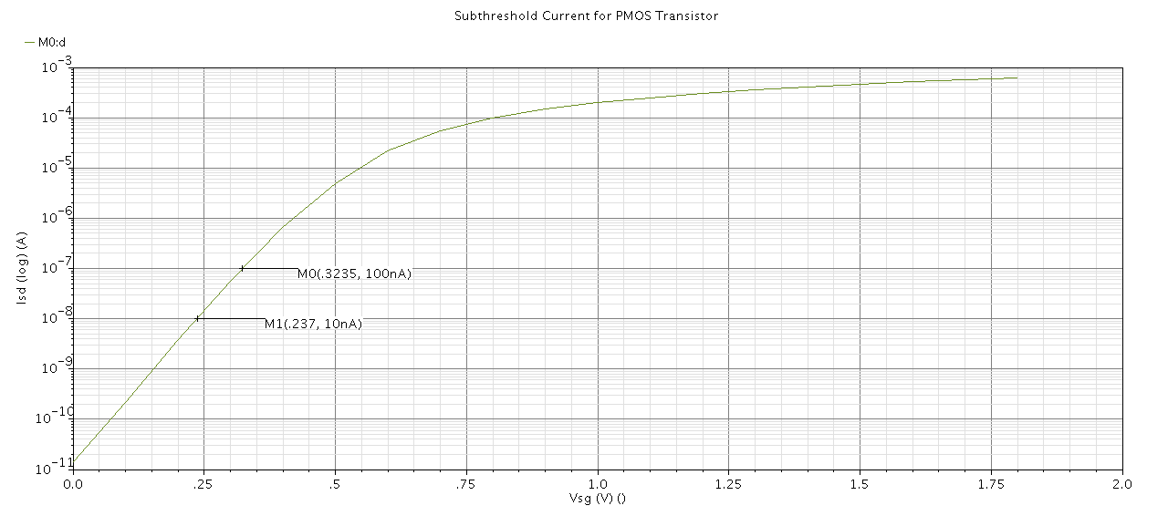

### *Figure 9: Subthreshold Current for PMOS Transistor*

## 2.4 Body Effect Analysis for NMOS and PMOS Transistors

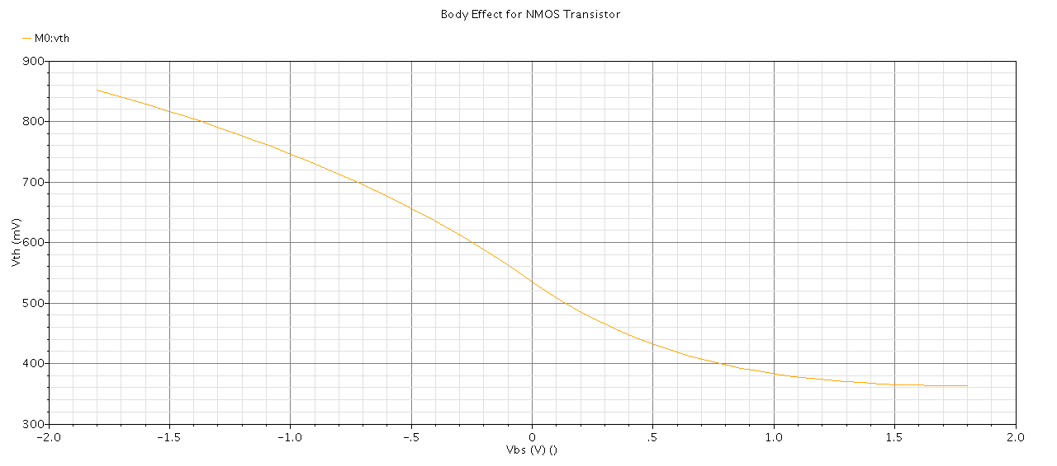

### *Figure 10: Body Effect Analysis for NMOS Transistor*

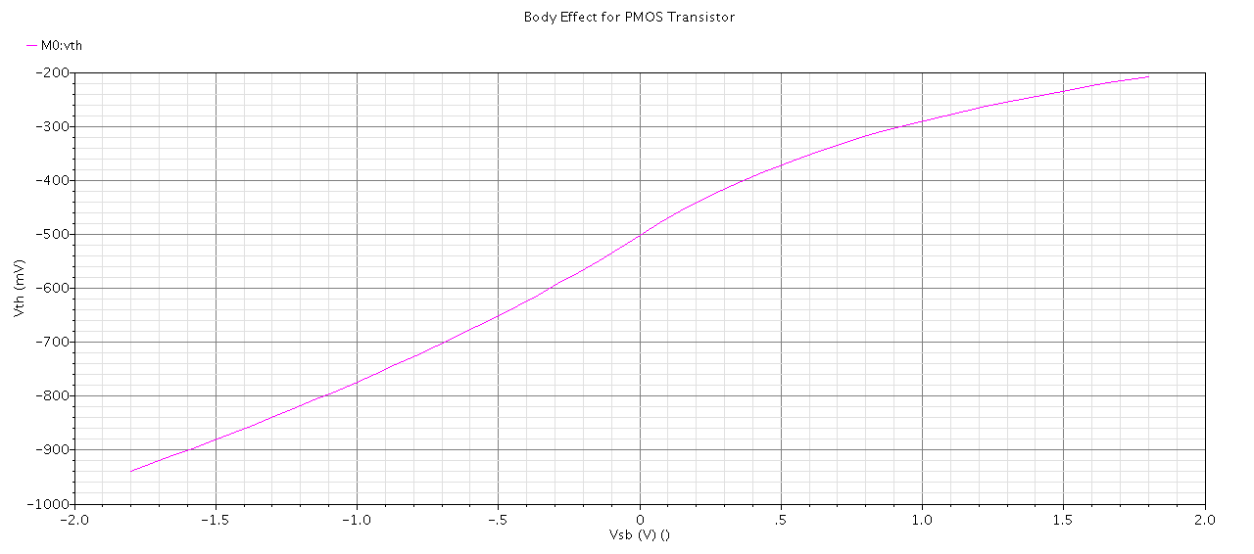

### *Figure 11: Body Effect Analysis for PMOS Transistor*

## 2.5 Layout and Extracted View of NMOS Transistor

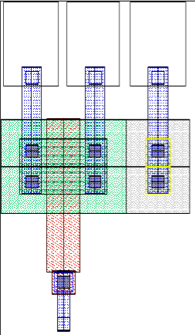

### *Figure 12: Layout View of NMOS Transistor*

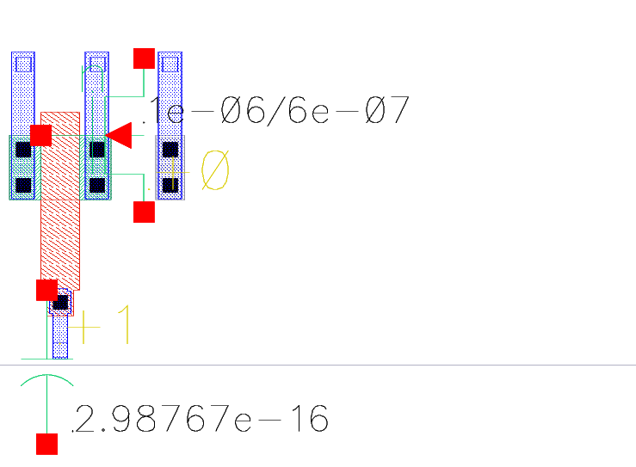

### *Figure 13: Extracted View of NMOS Transistor*

## 2.6 Family of I-V Characteristics of Waveforms for the Schematic and Extracted NMOS Transistor

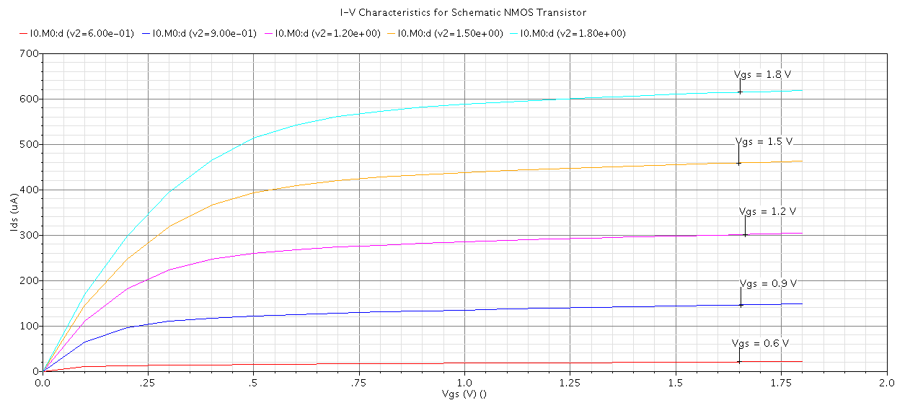

### *Figure 14: I-V Characteristics for Schematic NMOS Transistor*

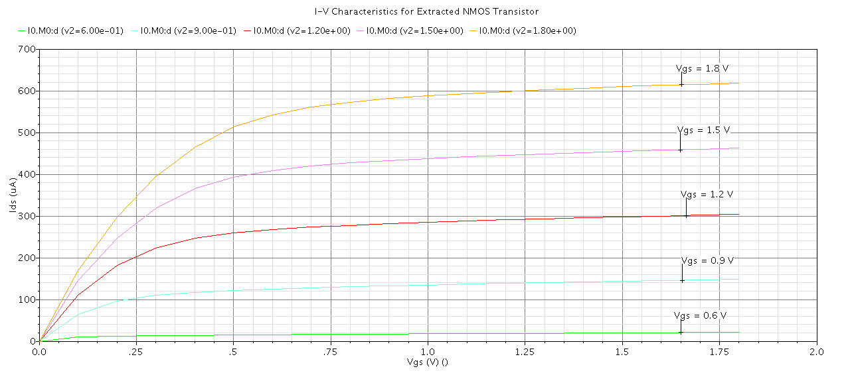

### *Figure 15: I-V Characteristics for Extracted NMOS Transistor*

## 3 Conclusion

The results recorded during the execution of the Lab for both the PMOS and NMOS transistors were very much identical to the results recorded in the prelab. After running the simulation in the Cadence software, technical difficulties did arise when the ‘dc-dc’ file and its sub-files were not displayed in the ‘Results Browser’. This was rectified by clearing the cache in the Results Browser by hovering over to ‘File->Clear’ and then running the simulation. Since the results in the prelab and post-lab were free of any discrepancies, it is safe to assume that the lab was executed successfully.